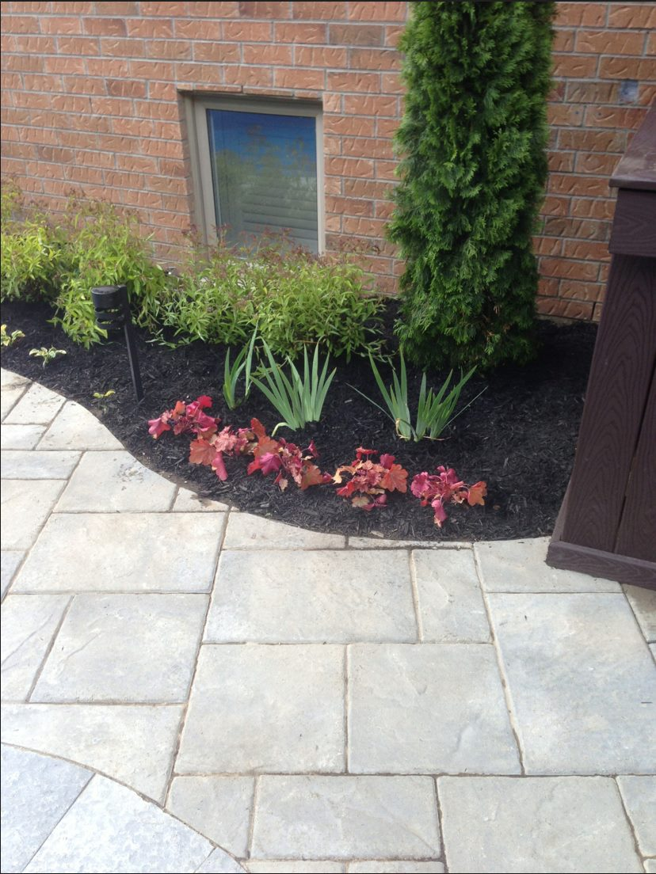

**PROFILE**

Take back your lawn, garden or commercial property and turn it into an inviting and usable space. For five years TAC Landscaping has put their customers first and treats each property with the highest level of quality and perfection. Contact TAC Landscaping today for a cost free quote.

**MISSION STATEMENT**

Take back your lawn, garden or commercial property and turn it into an inviting and usable space. For five years TAC Landscaping has put their customers first and treats each property with the highest level of quality and perfection. Contact TAC Landscaping today for a cost free quote.

TAC



TAKE A CHANCE

LANDSCAPING

1-234-5678

Lowest Costs Highest Quality

HOME

PROFILE

PORTFOLIO

CONTACT US

OUR TEAM



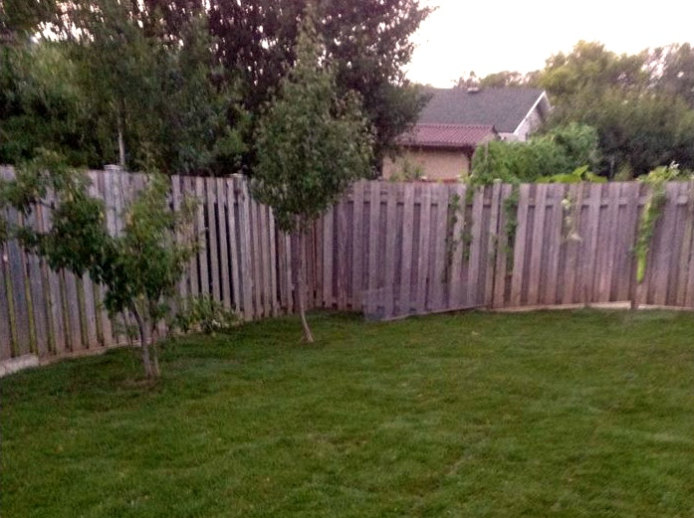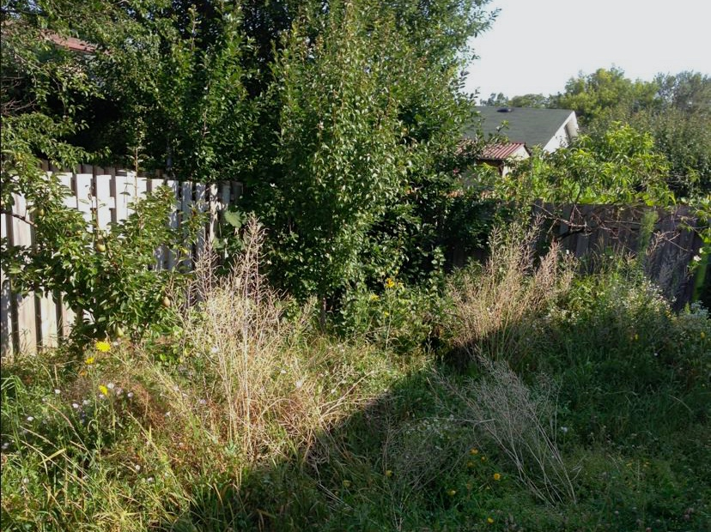

TAC



TAKE A CHANCE

LANDSCAPING

1-234-5678

Lowest Costs Highest Quality

HOME

PROFILE

PORTFOLIO

CONTACT US

OUR TEAM



HOME

PROFILE

PORTFOLIO

CONTACT US

OUR TEAM

TAKE A CHANCE

LANDSCAPING

1-234-5678

Lowest Costs Highest Quality

AFTER

BEFORE

**TAKE A CHANCE LANDSCAPING**

TAC Landscaping is a full service landscaping company specializing in landscape design and construction for residential and commercial properties. Our award winning design services create lasting and beautiful outdoor surroundings.

**Landscape Designs for Commercial, Home, and Garden**

Take back your lawn, garden or commercial property and turn it into an inviting and usable space. For five years TAC Landscaping has put their customers first and treats each property with the highest level of quality and perfection. Contact TAC Landscaping today for a cost free quote.